Display Module

Version 1.0

SHMT Co., Ltd.

REVISION HISTORY
Version | Detail(굴림/Verdana 10pt bold) | Name | Date
1.0

Technical documents
Copyright © 2006 Shmt Limited. All rights reserved.

Confidentiality Status
This document is NOT OPEN ACCESS. The distribution is restricted to certified company.
This document is CONFIDENTIAL.

Feedback on this document
If you have any comments on this document, please contact your channel to our company.

Shmt Web address
http://www.shmt.com

Contents
1. Display Module 11
1.1. Overview 11
1.1.1. Plane 12
2. Display & LCD Controller 13
2.1. Overview 13
2.1.1. Feature 13
2.1.2. Block Diagram 14
2.2. Operation 15
2.2.1. Overview 15
2.2.2. Graphic0 Plane 15
2.2.3. Graphic1 Plane 17
2.2.4. Background Plane 20
2.2.5. Video Plane 21
2.2.6. Plane Mixer 23
2.2.7. Timing Generator 24
2.2.8. Register Description 26
2.2.9. Registers 26
2.2.10. LCDMCON (LCD Controller Master Control) Register 27
2.2.11. LCDMSTS (LCD Controller Master Status) Register 28
2.2.12. GCON0 (Graphic0 Control) Register 29
2.2.13. GBLND0 (Graphic0 Blending) Register 29
2.2.14. GBMOD0 (Graphic0 Blending Mode) Register 30
2.2.15. GBASE0 (Graphic0 Stride Base) Register 31
2.2.16. GADDR0 (Graphic0 Base Address) Register 32
2.2.17. GPALA0 (Graphic0 Palette Memory) Register 33
2.2.18. BGCOL (Background Color) Register 33
2.2.19. GCON1 (Graphics1 Surface Control) Register 35
2.2.20. GBLND1 (Graphics1 Blending) Register 36
2.2.21. GBMOD1 (Graphics Blending Mode) Register 37
2.2.22. GBASE1 (Graphics1 Stride Base) Register 38
2.2.23. GADDR1 (Graphics1 Stream Control Address) Register 39
2.2.24. GPALA1 (Graphics1 Palette Memory) Register 40
2.2.25. GGAMMA00 (Graphic Gamma LUT Index) Register 41
2.2.26. GGAMMA01 (Graphic Gamma LUT Index) Register 41
2.2.27. GGAMMA02 (Graphic Gamma LUT Index) Register 42
2.2.28. GGAMMA03 (Graphic Gamma LUT Index) Register 42
2.2.29. GGAMMA04 (Graphic Gamma LUT Index) Register 43
2.2.30. GGAMMA05 (Graphic Gamma LUT Index) Register 43
2.2.31. GGAMMA06 (Graphic Gamma LUT Index) Register 44
2.2.32. GGAMMA07 (Graphic Gamma LUT Index) Register 44
2.2.33. GGAMMA08 (Graphic Gamma LUT Index) Register 45
2.2.34. GGAMMA09 (Graphic Gamma LUT Index) Register 45
2.2.35. GGAMMA0A (Graphic Gamma LUT Index) Register 46
2.2.36. GGAMMA0B (Graphic Gamma LUT Index) Register 46
2.2.37. GGAMMA0C (Graphic Gamma LUT Index) Register 47
2.2.38. GGAMMA0D (Graphic Gamma LUT Index) Register 47
2.2.39. GGAMMA0E (Graphic Gamma LUT Index) Register 48
2.2.40. GGAMMA0F (Graphic Gamma LUT Index) Register 48
2.2.41. GGAMMA10 (Graphic Gamma LUT Index) Register 49
2.2.42. VCON (Video Surface Control) Register 50
2.2.43. VBLND (Video Blending) Register 51
2.2.44. VBMOD (Video Blend Mode) Register 52
2.2.45. VBASE (Video Stride Base) Register 53
2.2.46. VADDR (Video Stream Even Address) Register 54
2.2.47. VADDR2 (Video Stream Odd Address) Register 54
2.2.48. VGAMMA00 (Video Gamma LUT Index) Register 55
2.2.49. VGAMMA01 (Graphic Gamma LUT Index) Register 55
2.2.50. VGAMMA02 (Graphic Gamma LUT Index) Register 56
2.2.51. VGAMMA03 (Graphic Gamma LUT Index) Register 56
2.2.52. VGAMMA04 (Graphic Gamma LUT Index) Register 57
2.2.53. VGAMMA05 (Graphic Gamma LUT Index) Register 57
2.2.54. VGAMMA06 (Graphic Gamma LUT Index) Register 58
2.2.55. VGAMMA07 (Graphic Gamma LUT Index) Register 58
2.2.56. VGAMMA08 (Graphic Gamma LUT Index) Register 59
2.2.57. VGAMMA09 (Graphic Gamma LUT Index) Register 59
2.2.58. VGAMMA0A (Graphic Gamma LUT Index) Register 60
2.2.59. VGAMMA0B (Graphic Gamma LUT Index) Register 60
2.2.60. VGAMMA0C (Graphic Gamma LUT Index) Register 61
2.2.61. VGAMMA0D (Graphic Gamma LUT Index) Register 61
2.2.62. VGAMMA0E (Graphic Gamma LUT Index) Register 62
2.2.63. VGAMMA0F (Graphic Gamma LUT Index) Register 62
2.2.64. VGAMMA10 (Graphic Gamma LUT Index) Register 63
2.2.65. LCDCON (LCD Control) Register 64
2.2.66. VIDCON (Video Control) Register 65
2.2.67. HSYNCCON0 (Horizontal Sync0) Register 66
2.2.68. HSYNCCON1 (Horizontal Sync1) Register 66
2.2.69. VSYNCCON0 (Vertical Sync0) Register 67
2.2.70. VSYNCCON1 (Vertical Sync1) Register 67
2.3. Operation Diagram 68

Figures

Figure 2-1 Display Module Block Diagram 14
Figure 2-2 LCDMCON Register Bits 27
Figure 2-3 LCDMSTS Register Bits 28
Figure 2-4 GBLND0 Register Bits 29
Figure 2-4 GBMOD0 Register Bits 30
Figure 2-4 GBASE0 Register Bits 31
Figure 2-4 GADDR0 Register Bits 32
Figure 2-4 GPALA0 Register Bits 33
Figure 2-4 BGCOL Register Bits 34
Figure 2-4 GCON1 Register Bits 35
Figure 2-4 GBLND1 Register Bits 36
Figure 2-4 GBMOD1 Register Bits 37
Figure 2-4 GBASE1 Register Bits 38
Figure 2-4 GADDR1 Register Bits 39
Figure 2-4 GPALA1 Register Bits 40
Figure 2-4 GGAMMA00 Register Bits 41
Figure 2-4 GGAMMA01 Register Bits 41
Figure 2-4 GGAMMA02 Register Bits 42
Figure 2-4 GGAMMA03 Register Bits 42
Figure 2-4 GGAMMA04 Register Bits 43
Figure 2-4 GGAMMA05 Register Bits 43
Figure 2-4 GGAMMA06 Register Bits 44
Figure 2-4 GGAMMA07 Register Bits 44
Figure 2-4 GGAMMA08 Register Bits 45
Figure 2-4 GGAMMA09 Register Bits 45
Figure 2-4 GGAMMA0A Register Bits 46
Figure 2-4 GGAMMA0B Register Bits 46
Figure 2-4 GGAMMA0C Register Bits 47
Figure 2-4 GGAMMA0D Register Bits 47
Figure 2-4 GGAMMA0ERegister Bits 48
Figure 2-4 GGAMMA0F Register Bits 48
Figure 2-4 GGAMMA10 Register Bits 49
Figure 2-4 VCON Register Bits 50
Figure 2-4 VBLND Register Bits 51
Figure 2-4 VBMOD Register Bits 52
Figure 2-4 VBASE Register Bits 53
Figure 2-4 VADDR Register Bits 54
Figure 2-4 VADDR2 Register Bits 54
Figure 2-4 VGAMMA00 Register Bits 55
Figure 2-4 VGAMMA01 Register Bits 55
Figure 2-4 VGAMMA02 Register Bits 56
Figure 2-4 VGAMMA03 Register Bits 56
Figure 2-4 VGAMMA04 Register Bits 57
Figure 2-4 VGAMMA05 Register Bits 57
Figure 2-4 VGAMMA06 Register Bits 58
Figure 2-4 VGAMMA07 Register Bits 58
Figure 2-4 VGAMMA08 Register Bits 59
Figure 2-4 VGAMMA09 Register Bits 59
Figure 2-4 VGAMMA0A Register Bits 60
Figure 2-4 VGAMMA0B Register Bits 60
Figure 2-4 VGAMMA0C Register Bits 61
Figure 2-4 VGAMMA0D Register Bits 61
Figure 2-4 VGAMMA0ERegister Bits 62
Figure 2-4 VGAMMA0F Register Bits 62
Figure 2-4 VGAMMA10 Register Bits 63
Figure 2-4 LCDCON Register Bits 64
Figure 2-4 VIDCON Register Bits 65
Figure 2-4 HSYNC0CON Register Bits 66
Figure 2-4 HSYNCCON1 Register Bits 66
Figure 2-4 VSYNCCON0 Register Bits 67
Figure 2-4 VSYNCCON1 Register Bits 67

Tables

Table 2-4 Registers (Base Address : ???? ????h) 24
Table 2-5 LCDMCON Register Description (Offset : 0000 0000h) 26
Table 2-6 LCDMSTS Register Description (Offset : 0000 0004h) 27
Table 2-7 GCON Register Description (Offset : 0000 0010h) 28
Table 2-7 GBLND0 Register Description (Offset : 0000 0014h) 28
Table 2-7 GBMOD0 Register Description (Offset : 0000 0018h) 29
Table 2-7 GBASE0 Register Description (Offset : 0000 001Ch) 30
Table 2-7 GADDR0 Register Description(Offset : 0000 0020h) 31
Table 2-7 GPALA0 Register Description (Offset : 0000 0024h) 32
Table 2-7 BGCOL Register Description(Offset : 0000 0030h) 33
Table 2-7 GCON1 Register Description (Offset : 0000 0040h) 34
Table 2-7 GBLND1 Register Description (Offset : 0000 0044h) 35
Table 2-7 GBMOD1 Register Description (Offset : 0000 0048h) 36
Table 2-7 GBASE1 Register Description(Offset : 0000 004Ch) 37
Table 2-7 GADDR1 Register Description(Offset : 0000 0050h) 38
Table 2-7 GPALA1 Register Description (Offset : 0000 005Ch) 39
Table 2-7 GGAMMA00 Register Description(Offset : 0000 0100h) 40
Table 2-7 GGAMMA01 Register Description(Offset : 0000 0104h) 40
Table 2-7 GGAMMA02 Register Description(Offset : 0000 0108h) 41
Table 2-7 GGAMMA03 Register Description(Offset : 0000 010Ch) 41
Table 2-7 GGAMMA04 Register Description(Offset : 0000 0110h) 42
Table 2-7 GGAMMA05 Register Description(Offset : 0000 0114h) 42
Table 2-7 GGAMMA06 Register Description(Offset : 0000 0118h) 43
Table 2-7 GGAMMA07 Register Description(Offset : 0000 011Ch) 43
Table 2-7 GGAMMA08 Register Description(Offset : 0000 0120h) 44
Table 2-7 GGAMMA09 Register Description(Offset : 0000 0124h) 44
Table 2-7 GGAMMA10 Register Description(Offset : 0000 0128h) 45
Table 2-7 GGAMMA07 Register Description(Offset : 0000 012Ch) 45
Table 2-7 GGAMMA0C Register Description(Offset : 0000 0130h) 46
Table 2-7 GGAMMA0DRegister Description(Offset : 0000 0134h) 46
Table 2-7 GGAMMA0E Register Description(Offset : 0000 0138h) 47
Table 2-7 GGAMMA0F Register Description(Offset : 0000 013Ch) 47
Table 2-7 GGAMMA10 Register Description(Offset : 0000 0140h) 48
Table 2-7 VCON Register Description(Offset : 0000 060h) 49
Table 2-7 VBLND Register Description(Offset : 0000 0064h) 50
Table 2-7 VBMOD Register Description (Offset : 0000 0068h) 51
Table 2-7 VBASE Register Description (Offset : 0000 006Ch) 52
Table 2-7 VADDR Register Description(Offset : 0000 0070h) 53
Table 2-7 VADDR2 Register Description(Offset : 0000 0074h) 53
Table 2-7 VGAMMA00 Register Description(Offset : 0000 0200h) 54
Table 2-7 VGAMMA01 Register Description(Offset : 0000 0204h) 54
Table 2-7 VGAMMA02 Register Description(Offset : 0000 0208h) 55
Table 2-7 VGAMMA03 Register Description(Offset : 0000 020Ch) 55
Table 2-7 VGAMMA04 Register Description(Offset : 0000 0210h) 56
Table 2-7 VGAMMA05 Register Description(Offset : 0000 0214h) 56
Table 2-7 VGAMMA06 Register Description(Offset : 0000 0218h) 57
Table 2-7 VGAMMA07 Register Description(Offset : 0000 021Ch) 57
Table 2-7 VGAMMA08 Register Description(Offset : 0000 0220h) 58
Table 2-7 VGAMMA09 Register Description(Offset : 0000 0224h) 58
Table 2-7 VGAMMA10 Register Description(Offset : 0000 0228h) 59
Table 2-7 VGAMMA07 Register Description(Offset : 0000 022Ch) 59
Table 2-7 VGAMMA0C Register Description(Offset : 0000 0230h) 60
Table 2-7 VGAMMA0DRegister Description(Offset : 0000 0234h) 60
Table 2-7 VGAMMA0E Register Description(Offset : 0000 0238h) 61
Table 2-7 VGAMMA0F Register Description(Offset : 0000 023Ch) 61
Table 2-7 VGAMMA10 Register Description(Offset : 0000 0240h) 62
Table 2-7 LCDCON Register Description(Offset : 0000 00E0h) 63
Table 2-7 VIDCON Register Description(Offset : 0000 00E4h) 64
Table 2-7 HSYNCCON0 Register Description(Offset : 0000 00F0h) 65
Table 2-7 HSYNCCON1 Register Description(Offset : 0000 00F4h) 65
Table 2-7 VSYNCCON0 Register Description(Offset : 0000 00F8h) 66
Table 2-7 VSYNCCON1 Register Description(Offset : 0000 00FCh) 66

Display Module

Overview

- BackGround/Video/Graphic/Graphic0 Plane 지원
- BackGround Plane은 단색만 지원
- Graphic0 Plane은 최대 1024x1024 사이즈 지원
- Graphic/Video Plane은 최대 2048x2048 사이즈 지원
- Video, Graphic, Graphic0 Plane은 Alpha blending(Global, Per Pixel)과 Chroma Key 지원
- Video/Graphic Plane 각각의 감마보정 기능 지원
- Graphic0/Graphic Plane에 8bpp 모드 지원을 위해 Palette RAM 필요
- TFT LCD Type 및 NTSC/PAL Video 출력 모드 지원
- 2048x2048 화면 처리 가능

Plane

본 Display Module에는 4개의 Plane을 가지고 있다.
각각 Video, Graphic, Graphic0, Background를 가지고 있다. 각 Plane이 지원하는 기능을 보면 다음과 같다.

Parameter | Planes
Parameter | Graphic | Video | Graphic0 | Background
Position (programmable) | 2 | 3 | 1 | 4
Resolution(max) | 2048x2048 | 2048x2048 | 1024x1024 | 1 color
RGB format | 8:8:8:8  5:5:5:1  5:6:5  8:8:8  8(Palletized) | YUV format  (4:2:2) | 3:3:2  5:5:5:1  5:6:5  8(Palletized) | 8:8:8
Bit per pixel | 8  16  32 | 16 | 8  16 | 24
Scaling factor | No | No | No | No
CSC | No | Yes | No | No
Gamma Correction | LUT(24x17),  Auto Gamma | LUT(24x17),  Auto Gamma | No | No
Global Alpha Blending | 8 | 8 | 8 | No
Per pixel Alpha Blending | 1 bit  8 bit | No | 1 bit | No
Destination Color Key | Yes | Yes | Yes | No
LCD/TV Output Format | 16(RGB565)  18(RGB666)  24(RGB888)

Display & LCD Controller

Overview

Feature

- BackGround/Video/Graphic1/Graphic0 Plane 지원
- 2048x2048 화면 처리 가능
- BackGround Plane은 단색만 지원
- Graphic0 Plane은 최대 1024x1024 사이즈 지원
- Graphic1/Video Plane은 최대 2048x2048 사이즈 지원
- Video, Graphic1, Graphic0 Plane은 Alpha blending(Global, Per Pixel)과 Chroma Key 지원
- Video/Graphic1 Plane 각각의 감마보정 기능 지원
- Graphic0/Graphic1 Plane에 8bpp 모드 지원을 위해 Palette RAM 필요
- TFT LCD Type 및 NTSC/PAL Video 출력 모드 지원

Block Diagram

Figure 2-1 Display Module Block Diagram
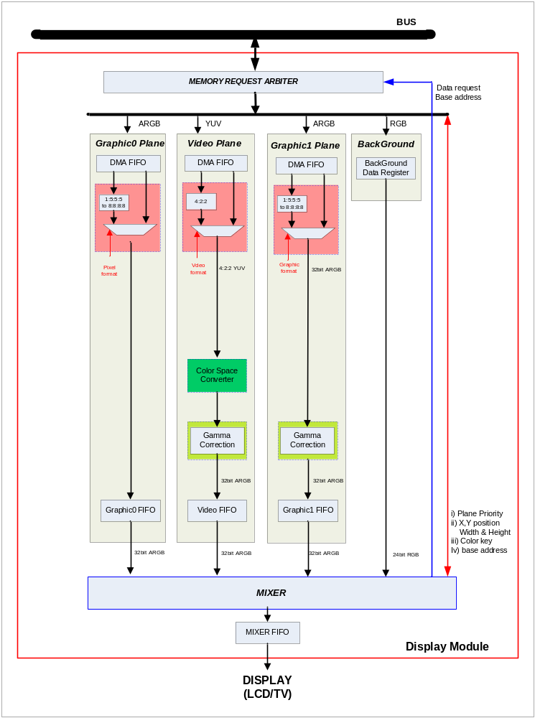

Operation

Overview

Graphic0, Graphic, Video, BackGround Plane이 Mixer 블록에서 Alpha Blending/Chroma-Key 되어 미리 설정된 화면에 맞게 뿌리는 역할을 한다.

Graphic0 Plane

Figure 2- Graphic0 Plane Setting
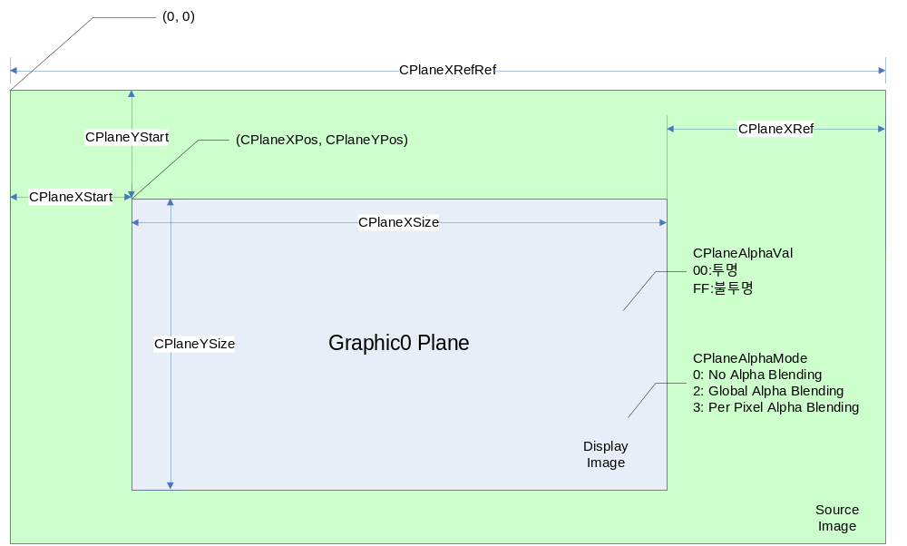

Graphic0 Plane은 최대 1024x1024의 소스 이미지를 처리할 수 있다. Palette Mode를 지원하고Alpha Blending을 지원하며 Gamma correction은 지원하지 않는다.
Graphic0 이미지는 메모리에 32bit Align 된 Little Endian 방식으로 저장되어 있어야 한다.

Pixel Format Support
    - Palette Mode(8bpp)
      - 미리 Palette Data를 만들어서 Palette 메모리에 넣어 줘야 한다
      - GIF Format이 이 모드를 지원한다.
      - Palette Data Update 중간에 이미지가 깨질 수 있다. → 화면 상으로는 느끼지 못할 것임
    - RGB332
    - ARGB1555
    - RGB565

Alpha Blending Mode
    - Global Alpha Blending
    - Per Pixel Alpha Blending
    - Pixel Alpha와 Global Alpha는 동시에 선택하면 Global Alpha만 적용된다.

Figure 2- Graphic Plane Hardware Block Diagram
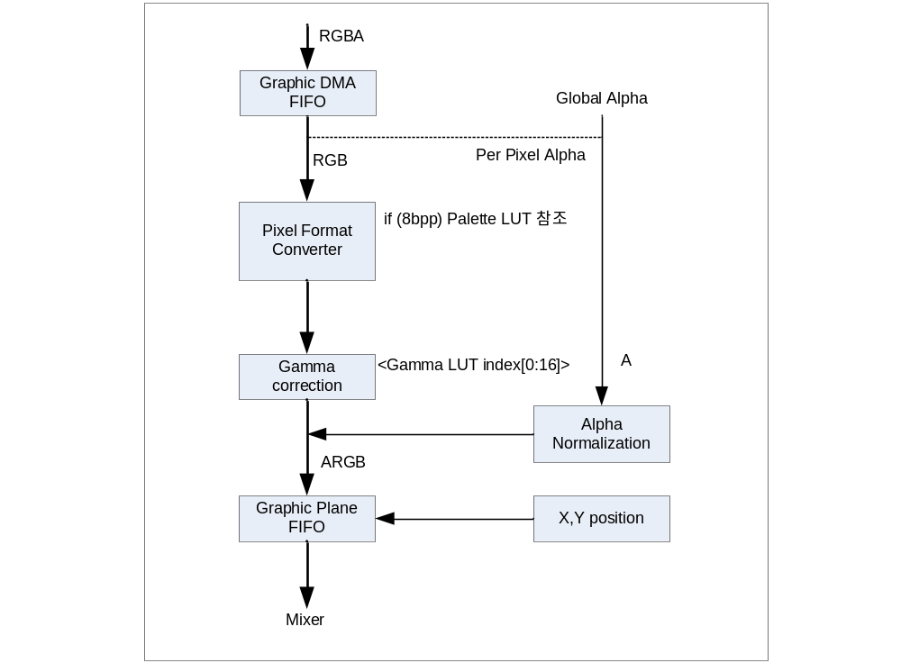

Graphic1 Plane

Figure 2- Graphic1 Plane Setting
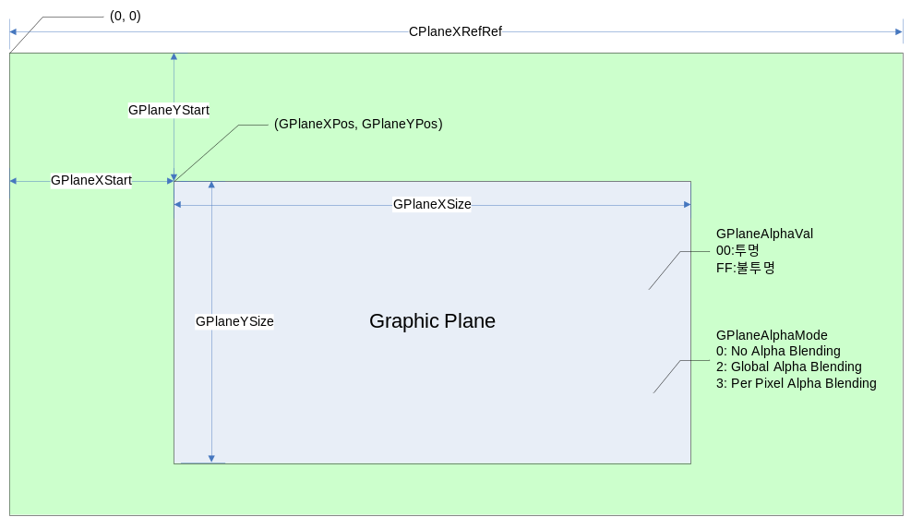

Graphic1 Plane은 최대 2048x2048의 소스 이미지를 처리할 수 있다.
Graphic1 이미지는 메모리에 32bit Align 된 Little Endian 방식으로 저장되어 있어야 한다.
Graphic1 Plane은 Palette Mode를 지원한다.

Pixel Format Support
    - Palette Mode(8bpp)
    - ARGB1555
    - RGB565
    - RGB888
    - ARGB8888

Alpha Blending Mode
    - Global Alpha Blending
    - Per Pixel Alpha Blending
    - Pixel Alpha와 Global Alpha는 동시에 선택하면 Global Alpha만 적용된다.

Gamma Correction

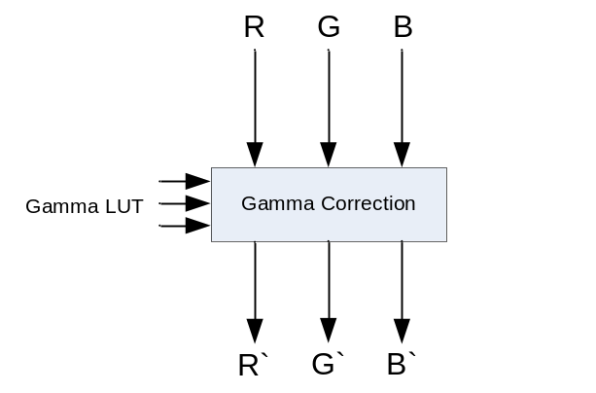
R' = T[κR] + ( T[κR+1] – T[κR] ) * (αR) /16
G' = T[κG] + ( T[κG+1] – T[κG] ) * αG) /16
B' = T[κB] + ( T[κB+1] – T[κB] ) * αB) /16

κR : the upper nibble of a Red
αR : the lower nibble of a Red

LUT | Gamma = 1.0 | Gamma = 1.4
0 | 0 | 0
1 | 16 | 35
2 | 32 | 57
3 | 48 | 77
4 | 64 | 95
5 | 80 | 111
6 | 96 | 127
7 | 112 | 141
8 | 128 | 156
9 | 144 | 169
10 | 160 | 182
11 | 176 | 195
12 | 192 | 208
13 | 208 | 220
14 | 224 | 232
15 | 240 | 244
16 | 255 | 255

The gamma corrected color value (for R, G, and B) is calculated by:
1) Lookup κR +1 in the LUT index column of Table.
2) Select the gamma value in the right columns of Table.
This is T[κR +1].
3) Lookup κR in the LUT index column of Table.
4) Select the gamma value in the right columns of Table.
This is T[κR].
5) Interpolate T[κR] and T[κR +1] using αR.
As an example, assume an RGB color of R=135, G=222, and B=053 (all values are decimal) being
gamma corrected using the gamma = 1.4 values in Table

RED
1) κR = upper nibble of 135 = 8
2) αR = lower nibble of 135 = 7
3) T[κR] = 156
4) T[κR +1] = 169
5) Interpolate T[κR] & T[κR +1]
6) Resulting red value is: 162
The same process can be applied to the original G and B values to obtain the gamma corrected pixel color.

*** Gamma를 Enable 하고 Chroma Key를 적용하면 Gamma에 의해 변형된 값의 Chroma Key를 적용해야 한다.
즉, 위의 1.4 Gamma를 적용할 경우에는 0xFFFFFF 대신 0xF2F2F2를 적용한다.

Background Plane

Figure 2- Background Plane Setting
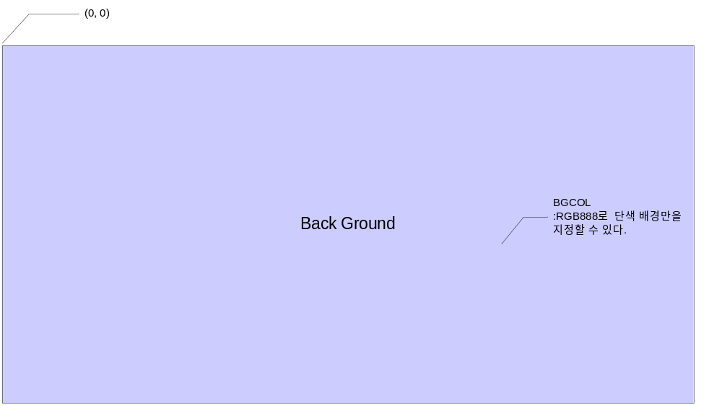
4개의 Plane중 우선 순위가 가장 낮은 Plane이다.
우선 순위가 높은 Plane이 투명하다면 Background 색상이 보이게 된다.

Video Plane

Figure 2- Video Plane Setting
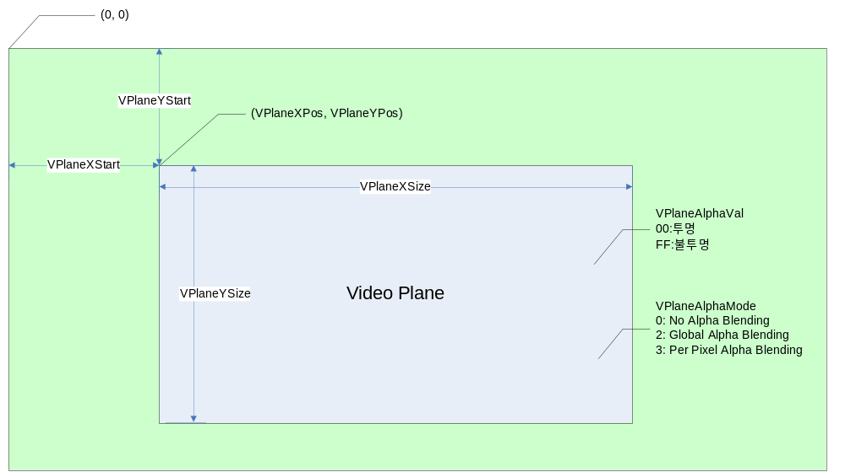

Video Plane은 최대 2048x2048의 입력 소스 이미지를 처리 할 수 있다.

Pixel Format Support
    - YUV422
      - 16bit YUV 4:2:2 UY0VY1 (U lsb) [UYVY / UYNV]
      - 16bit YUV 4:2:2 VY0UY1 (V lsb)
      - 16bit YUV 4:2:2 Y0UY1V (Y0 lsb) [YUY2 / YUNV / V422]
      - 16bit YUV 4:2:2 Y0VY1U (Y0 lsb) [YVYU]

Alpha Blending Mode
    - Global Alpha Blending

Color Space Conversion
    - Hardware YUV422 to RGB Conversion

Gamma Correction
    - Graphic Plane과 동일함.

Figure 2- Video Plane Block Diagram
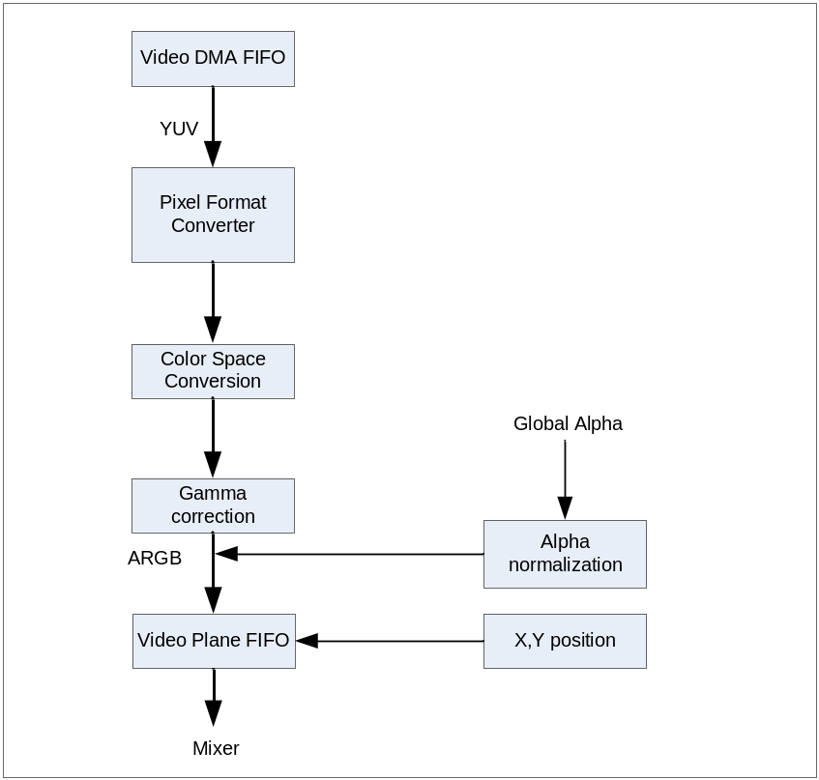

Plane Mixer

Figure 2- 5 Plane Mixer Block Diagram
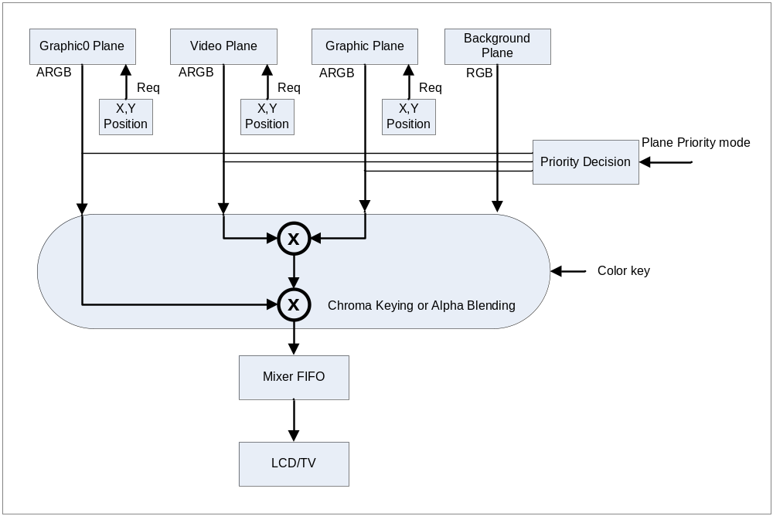

The four streams are combined by the mixer to create the final image that appears on the display. The mixer combines the streams based on their blend position (top, middle, bottom, background), alpha values, and chroma-key.

Plane Priority Select
Graphic0와 Background Plane의 Position은 고정되어 있고 Graphic, Video Plane에 대해서 Priority를 선택 할 수 있다.

Plane Chroma-Key & Alpha Blending
Plane priority가 결정되면, Chroma-Key와 Alpha Blending 중 하나를 수행 할 수 있다.

Plane Chroma-Key , the simple priority mode
Pview = Pnew (when Pnew does not match transparent color)
= Plower (when Pnew matches transparent color)

Alpha Blend mode
Pview = (Pnew × α) + Plower × (1 – α), (0≤α≤1)
(Upper image × Blend ratio) + (Lower image × (1 – Blend ratio))

→ Reduced Hardware Size
Pview = α(Pnew - Plower) + Plower, (0≤α≤1)

Timing Generator

최대 2048x2048의 Display가 가능하고, 설정된 Register의 값에 따라 Video Sync 및 LCD Sync를 생성하고, Plane Mixer의 Valid Data 정보를 전달한다.

Figure 2- Display Sync/Data Generation
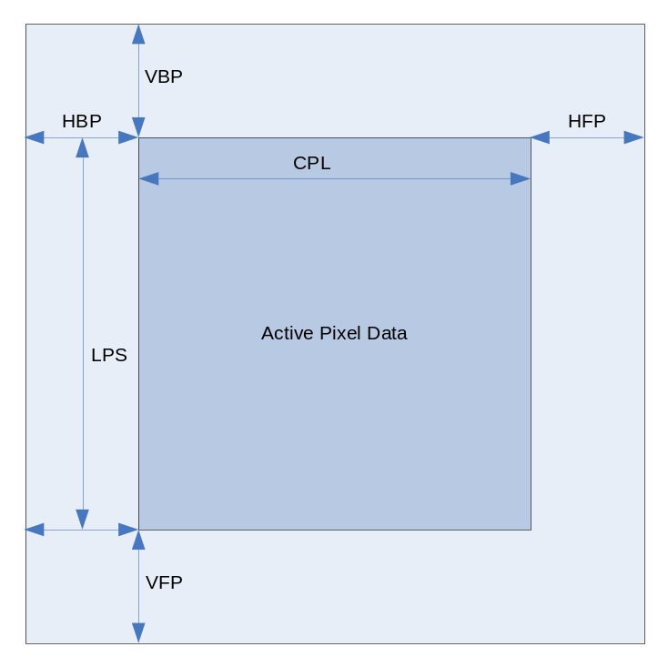

- HBP : Horizontal Back Porch
- HFP : Horizontal Front Porch
- CPL : Horizontal Active Pixel
- VBP : Vertical Back Porch
- VFP : Vertical Front Porch
- LPS : Vertical Active Line

Figure 2- Horizontal Sync / Blanking Types
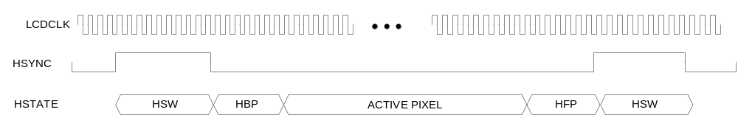

Figure 2- VSYNC Timing and Horizontal Line Types
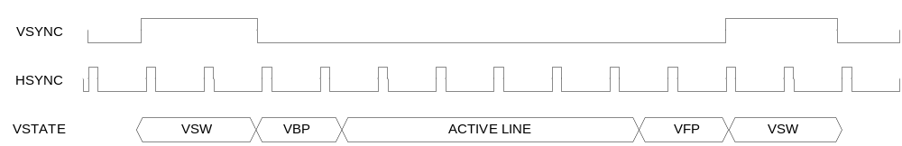

Register Description

Registers

Table 2-1 Registers (Base Address : ???? ????h)
Offset | Name | R/W | Description | Init. Value
0000h | LCDMCON | RW | LCD Controller Master Control Register | 0000 0000h
0004h | LCDMSTS | R | LCD Controller Master Status Register | 0000 0000h
0010h | GCON0 | RW | Graphic0 Control Register | 0000 0000h
0014h | GBLND0 | RW | Graphic0 Blending Register | 0000 0000h
0018h | GBMOD0 | RW | Graphic0 Blending Mode Register | 0000 0000h
001Ch | GBASE0 | RW | Graphic0 Stride Base Register | 0000 0000h
0020h | GADDR0 | RW | Graphic0 Stream Address Register
0024h | GPALM0 | RW | Graphic0 Palette Address Register | 0000 0000h
0030h | BGCOL | RW | Background Color Register | 0000 0000h
0040h | GCON1 | RW | Graphics1 Surface Control Register | 0000 0000h
0044h | GBLND1 | RW | Graphics1 Blending Register | 0000 0000h
0048h | GBMOD1 | RW | Graphics1 Blending Mode Register | 0000 0000h
004Ch | GBASE1 | RW | Graphics1 Stride Base Register | 0000 0000h
0050h | GADDR1 | RW | Graphics1 Stream Address Register | 0000 0000h
0054h | GPALM1 | RW | Graphics1 Palette Address Register
0100h~0140h | GGAMMA | RW | Graphics1 Gamma Slope Register
0060h | VCON | RW | Video Surface Control Register
0064h | VBLND | RW | Video Blending Register
0068h | VBMOD | RW | Video Blending Mode Register
006Ch | VBASE | RW | Video Stride Base Register
0070h | VADDR | RW | Video Stream Even Address Register
0078h | VADDR2 | RW | Video Stream Odd Address Register
0200h~0240h | VGAMMA | RW | Video Gamma Slope Register
00E0h | LCDCON | RW | LCD Control Register
00E4h | VIDCON | RW | NTSC/PAL Control Regsiter
00F0h | HSYNC0 | RW | Horizontal Sync0 Register
00F4h | HSYNC1 | RW | Horizontal Sync1 Register
00F8h | VSYNC0 | RW | Vertical Sync0 Register
00FCh | VSYNC1 | RW | Vertical Sync1 Register

LCDMCON (LCD Controller Master Control) Register

Figure 2-2 LCDMCON Register Bits
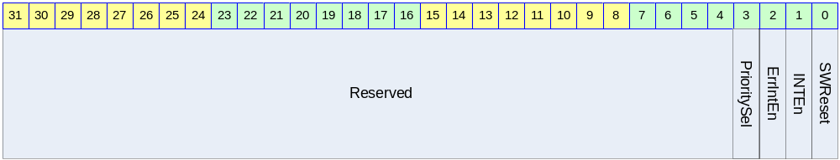

Table 2-2 LCDMCON Register Description (Offset : 0000 0000h)
Bits | Name | R/W | Description | Init. Value
[3] | PrioritySel | RW | Plane Position : 각 Plane에 대한 overlay priority bit. (Alpha Value 와 Colorkey setting에 따라 달라질 수 있음)  0 : Graphic0>Video>Graphic>Background  1 : Graphic0>Graphic>Video>Background | 00
[2] | ErrIntEn | RW | Dm Error Interrupt Enable
[1] | INTEn | RW | Interrupt Enable  전송이 시작되면 인터럽트를 걸지를 선택  1: Interrupt Enable  0: Interrupt Disable  * Video Mode일 경우에는 Even Field마다 발생한다. | 0
[0] | SWReset | W | Reset LCD Controller  1 : Reset  0 : Set  1을 write 했을 때 1cycle후 자동으로 0이 된다. | 0

LCDMSTS (LCD Controller Master Status) Register

Figure 2-3 LCDMSTS Register Bits
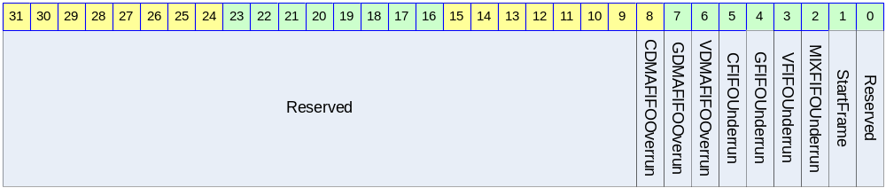

Table 2-3 LCDMSTS Register Description (Offset : 0000 0004h)
Bits | Name | R/W | Description | Init. Value
[31:9] |  |  | Reserved
[8] | CDMAFIFOOverrun | R | Graphic0 Plane DMA FIFO OverRun  이 레지스터를 읽으면 0으로 클리어된다. | 0
[7] | GDMAFIFOOverrun | R | Video Plane DMA FIFO OverRun  이 레지스터를 읽으면 0으로 클리어된다. | 0
[6] | VDMAFIFOOverrun | R | Graphic Plane DMA FIFO OverRun  이 레지스터를 읽으면 0으로 클리어된다. | 0
[5] | CFIFOUnderrun | R | Graphic0 Plane FIFO UnderRun  이 레지스터를 읽으면 0으로 클리어된다. | 0
[4] | GFIFOUnderrun | R | Video Plane FIFO UnderRun  이 레지스터를 읽으면 0으로 클리어된다. | 0
[3] | VFIFOUnderrun | R | Graphic Plane FIFO UnderRun  이 레지스터를 읽으면 0으로 클리어된다. | 0
[2] | MIXFIFOUnderrun | R | Mixer FIFO UnderRun  이 레지스터를 읽으면 0으로 클리어된다. | 0
[1] | StartFrame | R | Start of Frame  이 레지스터를 읽으면 0으로 클리어된다. | 0
[0] | EvenField | R | Even Field Indication  이 레지스터를 읽으면 0으로 클리어된다.

GCON0 (Graphic0 Control) Register

Figure 2-5 GCON0 Register Bits
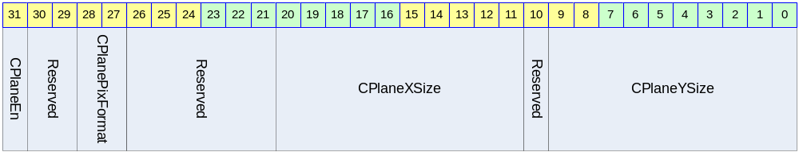

Table 2-4 GCON Register Description (Offset : 0000 0010h)
Bits | Name | R/W | Description | Init. Value
[31] | CPlaneEn | RW | Graphic0 Plane Enable | 0
[29] |  |  | Reserved
[28:27] | CPlanePixFormat | RW | Graphic0 Pixel Format  0: 8bbp [RGB]  1: 8-bit rgb332 [RGB]  2: 1-bit alpha + 15bit rgb555[ARGB]  3: rgb565[RGB565] | 0
[26:21] |  |  | Reserved
[20:11] | CPlaneXSize | RW | Graphic0 Surface Width | 64
[9:0] | CplaneYSize | RW | Graphic0 Surface Height | 64

GBLND0 (Graphic0 Blending) Register

Figure 2-4 GBLND0 Register Bits
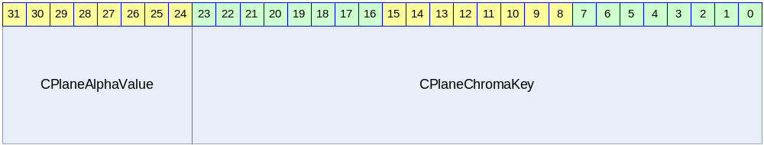

Table 2-5 GBLND0 Register Description (Offset : 0000 0014h)
Bits | Name | R/W | Description | Init. Value
[31:24] | CplaneAlphaValue | RW | 0x00: Low Priority Plane Displayed  0xFF: Graphic0 Plane Displayed | 0
[23:0] | CplaneChromaKey | RW | Color Key for Stream : RGB format | 0

GBMOD0 (Graphic0 Blending Mode) Register

Figure 2-5 GBMOD0 Register Bits
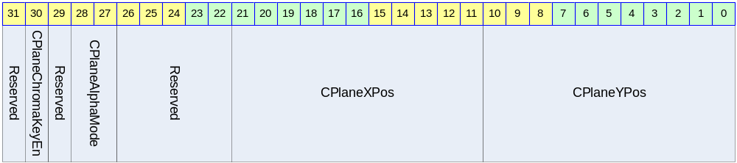

Table 2-6 GBMOD0 Register Description (Offset : 0000 0018h)
Bits | Name | R/W | Description | Init. Value
[30] | CplaneChromaKeyEn | RW | Color Key Enable  0: Color keying disabled(Alpha Blend Mode)  1: Color Keying enable | 0
[29] |  |  | Reserved
[28:27] | CPlaneAlphaMode | RW | 0 : No Alpha Blending  2 : Global Alpha Blending  3 : Per Pixel Alpha Blending  0x00 : Transparency  0xFF : opaque | 0
[26:22] |  |  | Reserved
[21:11] | CPlaneXPos | RW | X Position Start : X position of top left corner of display | 0
[10:0] | CPlaneYPos | RW | Y Position Start : Y position of top left corner of display | 0

GBASE0 (Graphic0 Stride Base) Register

Figure 2-6 GBASE0 Register Bits
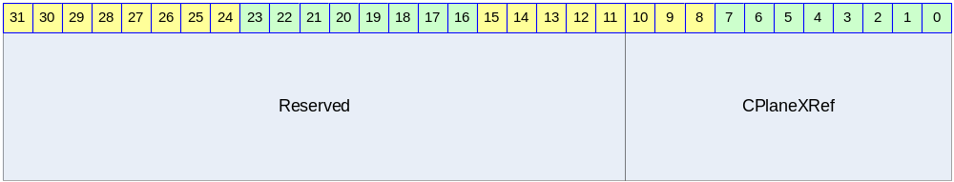

Table 2-7 GBASE0 Register Description (Offset : 0000 001Ch)
Bits | Name | R/W | Description | Init. Value
[31:11] |  |  | Reserved
[10:0] | CPlaneXRef | RW | Source X Position Stride  Pixel Format(CPlanePixFormat)에 의하여  입력은 다음과 같이 넣어준다.  CPlaneXRefRef – CplaneXSizeRef  CPlaneXRefRef는  2, 3 : CPlaneXSrcSize>>1  0 : CPlaneXSrcSize>>2  CPlaneXSizeRef는  2, 3 : CPlaneXSize>>1  0 : CPlaneXSize>>2 | 1111111111b

GADDR0 (Graphic0 Base Address) Register

Figure 2-7 GADDR0 Register Bits
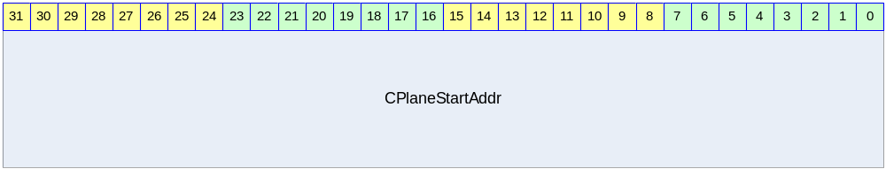

Table 2-8 GADDR0 Register Description(Offset : 0000 0020h)
Bits | Name | R/W | Description | Init. Value
[31:0] | CPlaneStartAddr | RW | Graphic0 Stream Control Address Register  CPlaneBASE + (CPlaneXStartRef + (CPlaneYStart * CPlaneXRefRef))<<2  CPlaneBASE : Frame Memory Base Address  CPlaneXStartRef : CPlanePixFormat에 의한 실제 DMA할 Source의 X Start Position이다.  Pixel Format(CPlanePixFormat) 에 따라  2, 3 : CPlaneXStart>>1  0 : CPlaneXStart>>2  (Read시에는 Current DMA Address를 가리킨다.) | 0

GPALA0 (Graphic0 Palette Memory) Register

Figure 2-8 GPALA0 Register Bits
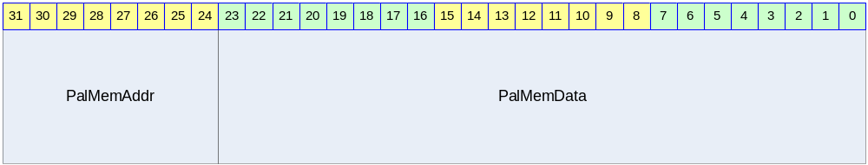

Table 2-9 GPALA0 Register Description (Offset : 0000 0024h)
Bits | Name | R/W | Description | Init. Value
[31:24] | G0PalMemAddr | RW | Graphic0 Palette Memory Address | 0
[23:0] | G0PalMemData | RW | Graphic0 Palette Memory

BGCOL (Background Color) Register

Figure 2-9 BGCOL Register Bits
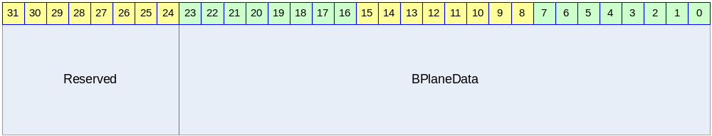

Table 2-10 BGCOL Register Description(Offset : 0000 0030h)
Bits | Name | R/W | Description | Init. Value
[31:24] |  |  | Reserved
[23:0] | BPlaneData | RW | Background Color : RGB888 | 0

GCON1 (Graphics1 Surface Control) Register

Figure 2-10 GCON1 Register Bits
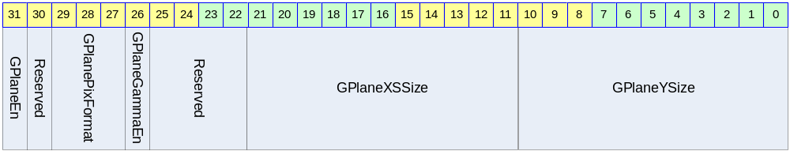

Table 2-11 GCON1 Register Description (Offset : 0000 0040h)
Bits | Name | R/W | Description | Init. Value
[31] | GplaneEn | RW | Graphic1 Plane Enable | 0
[30] |  |  | Reserved
[29:27] | GPlanePixFormat | RW | Graphics Pixel format  0b000 : 8bpp [RGB]  0b010 : 16-bit rgb565 [RGB]  0b011 : 1-bit alpha + 15-bit rgb555 [ARGB]  0b100 : 24-bit rgb888 [RGB]  0b101 : 8-bit alpha + 24-bit rgb888 [ARGB] | 0
[26] | GPlaneGammaEn | RW | Gamma LUT interpolation Enable  0 : bypass Gamma  1 : enable Gamma | 0
[25:22] |  |  | Reserved
[21:11] | GPlaneXSize | RW | Graphics1 Surface Width (Maximum of 2048) | 2047
[10:0] | GPlaneYSize | RW | Graphics1 Surface Height (Maximum of 2048) | 2047

GBLND1 (Graphics1 Blending) Register

Figure 2-11 GBLND1 Register Bits
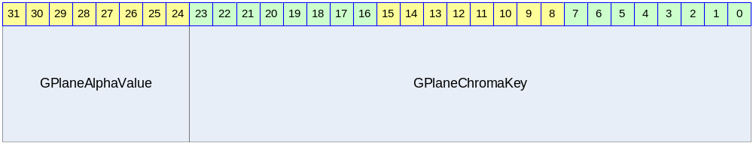

Table 2-12 GBLND1 Register Description (Offset : 0000 0044h)
Bits | Name | R/W | Description | Init. Value
[31:24] | GPlaneAlphaValue | RW | 0x00 : Low Priority Plane Displayed  0xFF : Current Plane Displayed | 0
[23:0] | GPlaneChromaKey | RW | Color Key for Stream : RGB format | 0

GBMOD1 (Graphics Blending Mode) Register

Figure 2-12 GBMOD1 Register Bits
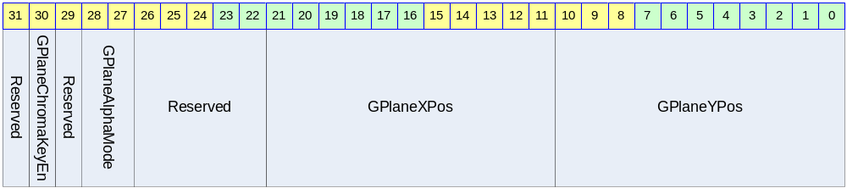

Table 2-13 GBMOD1 Register Description (Offset : 0000 0048h)
Bits | Name | R/W | Description | Init. Value
[30] | GPlaneChromaKeyEn | RW | Color Key Enable  0 : Color keying disabled  1 : Color keying enabled | 0
[29] |  |  | Reserved
[28:27] | GPlaneAlphaMode | RW | 0 : No Alpha Blending  2 : Global Alpha Blending  3 : Per Pixel Alpha Blending  0x00 : Transparency  0xFF : opaque | 0
 |  |  | Reserved
[21:11] | GPlaneXPos | RW | X Position Start : X position of top left corner of display | 0
[10:0] | GPlaneYPos | RW | Y Position Start : Y position of top left corner of display | 0

GBASE1 (Graphics1 Stride Base) Register

Figure 2-13 GBASE1 Register Bits
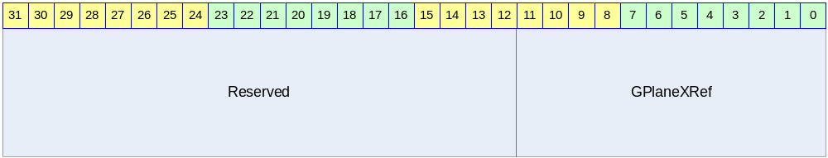

Table 2-14 GBASE1 Register Description(Offset : 0000 004Ch)
Bits | Name | R/W | Description | Init. Value
[31:12] |  |  | Reserved
[11:0] | GPlaneXRef | RW | Source X Position Stride  GPlaneXRefRef – GplaneXSizeRef  Graphic0의 계산 방법과 같다. | 0

GADDR1 (Graphics1 Stream Control Address) Register

Figure 2-14 GADDR1 Register Bits
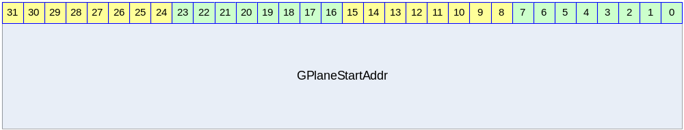

Table 2-15 GADDR1 Register Description(Offset : 0000 0050h)
Bits | Name | R/W | Description | Init. Value
[31:0] | GPlaneStartAddr | RW | Graphics Base Address  Read시에는 Current DMA Address를 가리킨 다.  Graphic0의 계산 방법과 같다. | 0

GPALA1 (Graphics1 Palette Memory) Register

Figure 2-15 GPALA1 Register Bits

Table 2-16 GPALA1 Register Description (Offset : 0000 005Ch)
Bits | Name | R/W | Description | Init. Value
[31:24] | G1PalMemAddr | RW | Graphic1 Palette Memory Address | 0
[23:0] | G1PalMemData | RW | Graphic1 Palette Memory Data

GGAMMA00 (Graphic Gamma LUT Index) Register

Figure 2-16 GGAMMA00 Register Bits
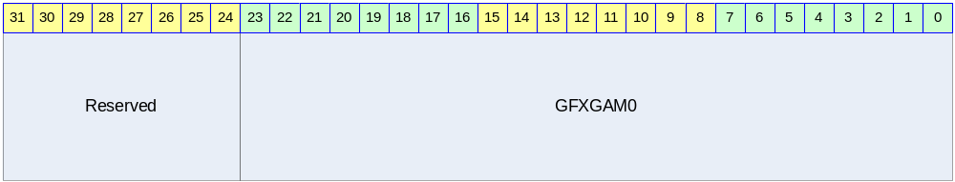

Table 2-17 GGAMMA00 Register Description(Offset : 0000 0100h)
Bits | Name | R/W | Description | Init. Value
[23:0] | GFXGAM0 | RW | Gamma Index0 | 0000 0000h

GGAMMA01 (Graphic Gamma LUT Index) Register

Figure 2-17 GGAMMA01 Register Bits
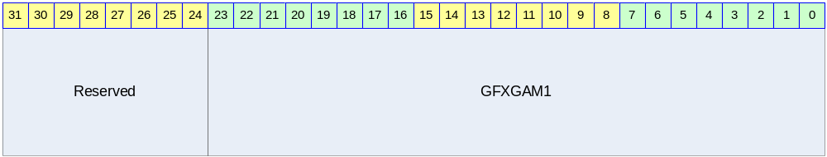

Table 2-18 GGAMMA01 Register Description(Offset : 0000 0104h)
Bits | Name | R/W | Description | Init. Value
[23:0] | GFXGAM1 | RW | Gamma Index1 | 0010 1010h

GGAMMA02 (Graphic Gamma LUT Index) Register

Figure 2-18 GGAMMA02 Register Bits
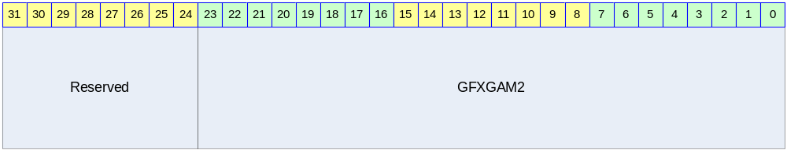

Table 2-19 GGAMMA02 Register Description(Offset : 0000 0108h)
Bits | Name | R/W | Description | Init. Value
[23:0] | GFXGAM2 | RW | Gamma Index2 | 0020 2020h

GGAMMA03 (Graphic Gamma LUT Index) Register

Figure 2-19 GGAMMA03 Register Bits
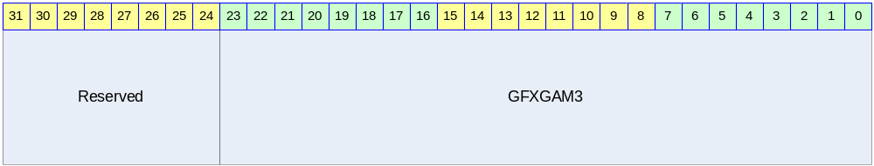

Table 2-20 GGAMMA03 Register Description(Offset : 0000 010Ch)
Bits | Name | R/W | Description | Init. Value
[23:0] | GFXGAM3 | RW | Gamma Index3 | 0030 3030h

GGAMMA04 (Graphic Gamma LUT Index) Register

Figure 2-20 GGAMMA04 Register Bits
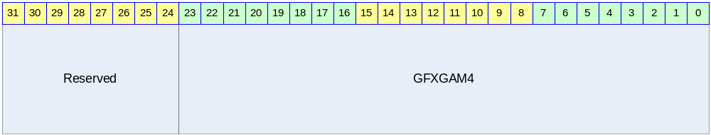

Table 2-21 GGAMMA04 Register Description(Offset : 0000 0110h)
Bits | Name | R/W | Description | Init. Value
[23:0] | GFXGAM4 | RW | Gamma Index4 | 0040 4040h

GGAMMA05 (Graphic Gamma LUT Index) Register

Figure 2-21 GGAMMA05 Register Bits
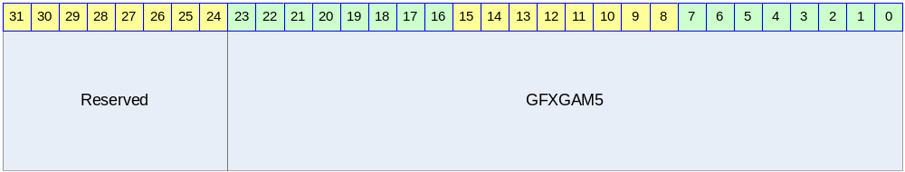

Table 2-22 GGAMMA05 Register Description(Offset : 0000 0114h)
Bits | Name | R/W | Description | Init. Value
[23:0] | GFXGAM5 | RW | Gamma Index5 | 0050 5050h

GGAMMA06 (Graphic Gamma LUT Index) Register

Figure 2-22 GGAMMA06 Register Bits
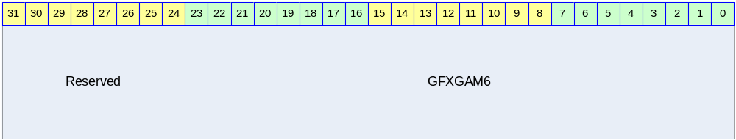

Table 2-23 GGAMMA06 Register Description(Offset : 0000 0118h)
Bits | Name | R/W | Description | Init. Value
[23:0] | GFXGAM6 | RW | Gamma Index6 | 0060 6060h

GGAMMA07 (Graphic Gamma LUT Index) Register

Figure 2-23 GGAMMA07 Register Bits
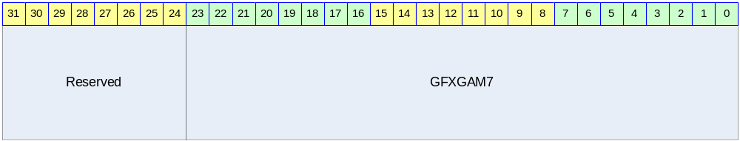

Table 2-24 GGAMMA07 Register Description(Offset : 0000 011Ch)
Bits | Name | R/W | Description | Init. Value
[23:0] | GFXGAM7 | RW | Gamma Index7 | 0070 7070h

GGAMMA08 (Graphic Gamma LUT Index) Register

Figure 2-24 GGAMMA08 Register Bits
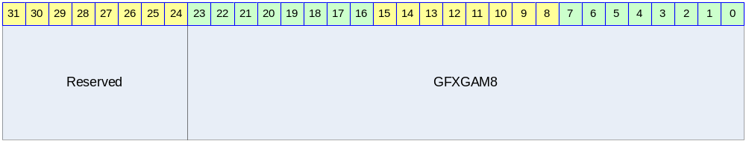

Table 2-25 GGAMMA08 Register Description(Offset : 0000 0120h)
Bits | Name | R/W | Description | Init. Value
[23:0] | GFXGAM8 | RW | Gamma Index8 | 0080 8080h

GGAMMA09 (Graphic Gamma LUT Index) Register

Figure 2-25 GGAMMA09 Register Bits
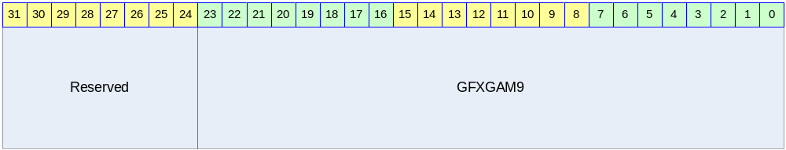

Table 2-26 GGAMMA09 Register Description(Offset : 0000 0124h)
Bits | Name | R/W | Description | Init. Value
[23:0] | GFXGAM9 | RW | Gamma Index9 | 0090 9090h

GGAMMA0A (Graphic Gamma LUT Index) Register

Figure 2-26 GGAMMA0A Register Bits
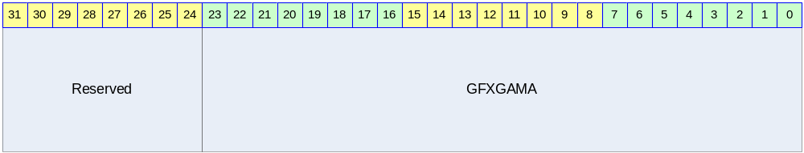

Table 2-27 GGAMMA10 Register Description(Offset : 0000 0128h)
Bits | Name | R/W | Description | Init. Value
[23:0] | GFXGAMA | RW | Gamma Index A | 00A0 A0A0h

GGAMMA0B (Graphic Gamma LUT Index) Register

Figure 2-27 GGAMMA0B Register Bits
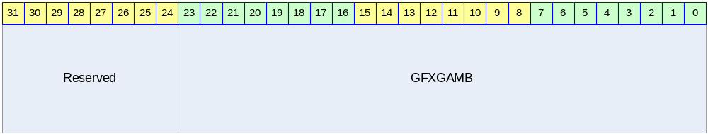

Table 2-28 GGAMMA07 Register Description(Offset : 0000 012Ch)
Bits | Name | R/W | Description | Init. Value
[23:0] | GFXGAMB | RW | Gamma Index B | 00B0 B0B0h

GGAMMA0C (Graphic Gamma LUT Index) Register

Figure 2-28 GGAMMA0C Register Bits
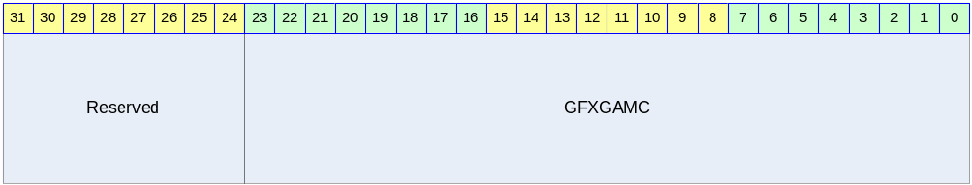

Table 2-29 GGAMMA0C Register Description(Offset : 0000 0130h)
Bits | Name | R/W | Description | Init. Value
[23:0] | GFXGAMC | RW | Gamma Index C | 00C0 C0C0h

GGAMMA0D (Graphic Gamma LUT Index) Register

Figure 2-29 GGAMMA0D Register Bits
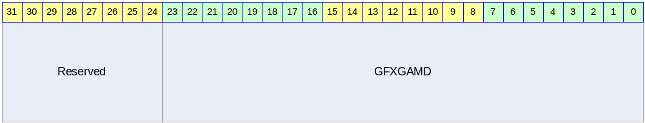

Table 2-30 GGAMMA0DRegister Description(Offset : 0000 0134h)
Bits | Name | R/W | Description | Init. Value
[23:0] | GFXGAMD | RW | Gamma Index D | 00D0 D0D0h

GGAMMA0E (Graphic Gamma LUT Index) Register

Figure 2-30 GGAMMA0ERegister Bits
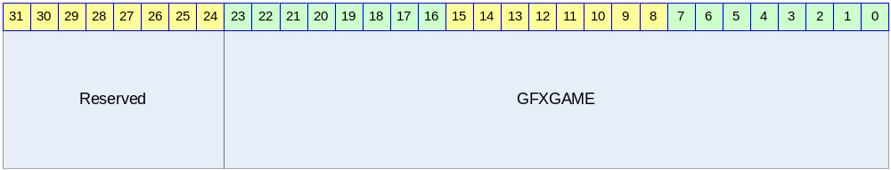

Table 2-31 GGAMMA0E Register Description(Offset : 0000 0138h)
Bits | Name | R/W | Description | Init. Value
[23:0] | GFXGAME | RW | Gamma Index E | 00E0 E0E0h

GGAMMA0F (Graphic Gamma LUT Index) Register

Figure 2-31 GGAMMA0F Register Bits
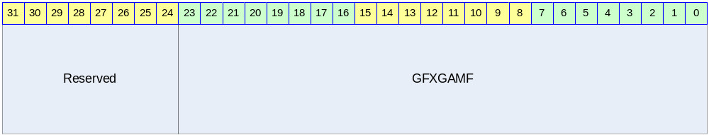

Table 2-32 GGAMMA0F Register Description(Offset : 0000 013Ch)
Bits | Name | R/W | Description | Init. Value
[23:0] | GFXGAMF | RW | Gamma Index F | 00F0 F0F0h

GGAMMA10 (Graphic Gamma LUT Index) Register

Figure 2-32 GGAMMA10 Register Bits
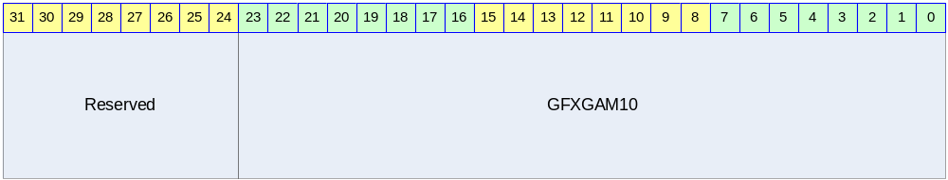

Table 2-33 GGAMMA10 Register Description(Offset : 0000 0140h)
Bits | Name | R/W | Description | Init. Value
[23:0] | GFXGAM10 | RW | Gamma Index 10 | 00FF FFFFh

VCON (Video Surface Control) Register

Figure 2-33 VCON Register Bits
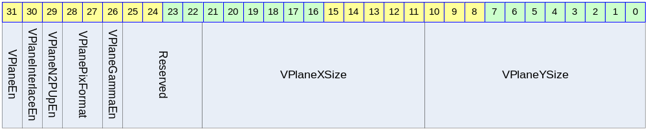

Table 2-34 VCON Register Description(Offset : 0000 060h)
Bits | Name | R/W | Description | Init. Value
[31] | VPlaneEn | RW | Video Plane Enable | 0
[30] | VPlaneInterfaceEn | RW | Interface Video Enable  Use Source is Interlace Video and Display is Processive | 0
[29] | VPlaneN2PUpEn | RW | 0 : Normal  1 : Add 1 Line each 5 Line Enable  Use Source is 720x480 and Display is 720x576
[28:27] | VPlanePixFormat | RW | Video Pixel format  0b00 : 16bit YUV 4:2:2 UY0VY1 (U lsb) [UYVY / UYNV]  0b01 : 16-bi t YUV 4:2:2 VY0UY1 (V lsb)  0b10 : 16-bit YUV 4:2:2 Y0UY1V (Y0 lsb) [YUY2 / YUNV / V422]  0b11 : 16-bit YUV 4:2:2 Y0VY1U (Y0 lsb) [YVYU] | 0
[26] | VPlaneGammaEn | RW | Gamma LUT interpolation Enable  0 : bypass Gamma  1 : enable Gamma | 0
[25:22] |  |  | Reserved
[21:11] | VPlaneXSize | RW | Video Surface Width (Maximum of 2047) | 2047
[10:0] | VPlaneYSize | RW | Video Surface Height (Maximum of 2047) | 2047

VBLND (Video Blending) Register

Figure 2-34 VBLND Register Bits
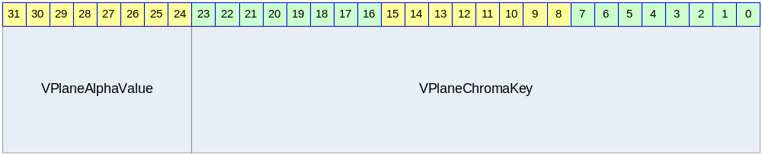

Table 2-35 VBLND Register Description(Offset : 0000 0064h)
Bits | Name | R/W | Description | Init. Value
[31:24] | VPlaneAlphaValue | RW | 0x00 : Low Priority Plane Displayed  0xFF : Current Plane Displayed | 0
[23:0] | VPlaneChromaKey | RW | Color Key for Stream : RGB format | 0

VBMOD (Video Blend Mode) Register

Figure 2-35 VBMOD Register Bits
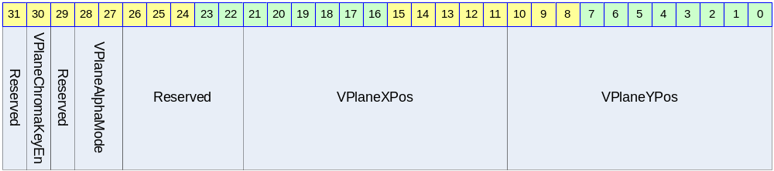

Table 2-36 VBMOD Register Description (Offset : 0000 0068h)
Bits | Name | R/W | Description | Init. Value
[30] | VPlaneChromaKeyEn | RW | Color Key Enable  0 : Color keying disabled  1 : Color keying enabled | 0
[30] |  |  | Reserved
[28:27] | VPlaneAlphaMode | RW | 0 : No Alpha Blending  2 : Global Alpha Blending  0x00 : Transparency  0xFF : opaque | 0
[26:22] |  |  | Reserved
[21:11] | VPlaneXPos | RW | X Position Start : X position of top left corner of display | 0
[10:0] | VPlaneYPos | RW | Y Position Start : Y position of top left corner of display | 0

VBASE (Video Stride Base) Register

Figure 2-36 VBASE Register Bits
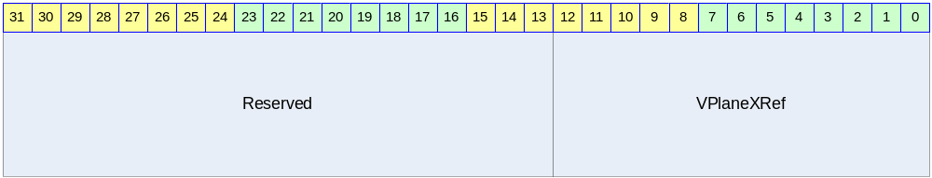

Table 2-37 VBASE Register Description (Offset : 0000 006Ch)
Bits | Name | R/W | Description | Init. Value
[31:12] |  |  | Reserved
[11:0] | VPlaneXRef | RW | Source X Position Stride  VPlaneXRefRef – VplaneXSizeRef  Graphic0의 계산 방법과 같다. | 0

VADDR (Video Stream Even Address) Register

Figure 2-37 VADDR Register Bits
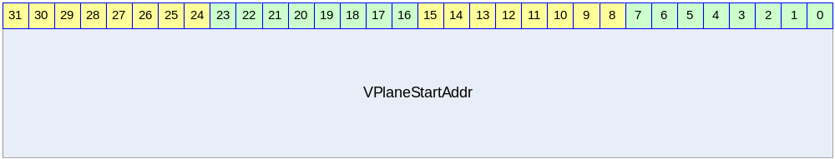

Table 2-38 VADDR Register Description(Offset : 0000 0070h)
Bits | Name | R/W | Description | Init. Value
[31:0] | VPlaneStartAddr | RW | Video Base Even Address  Read시에는 Current DMA Address를 가리킨 다.  Graphic0의 계산 방법과 같다. | 0

VADDR2 (Video Stream Odd Address) Register

Figure 2-38 VADDR2 Register Bits
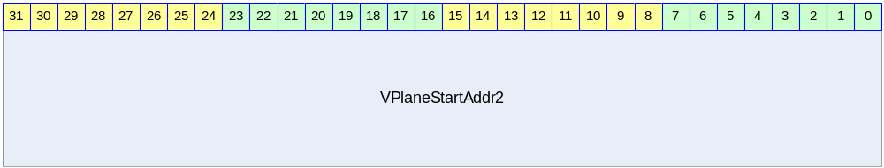

Table 2-39 VADDR2 Register Description(Offset : 0000 0074h)
Bits | Name | R/W | Description | Init. Value
[31:0] | VPlaneStartAddr2 | W | Video Base Odd Address | 0

VGAMMA00 (Video Gamma LUT Index) Register

Figure 2-39 VGAMMA00 Register Bits
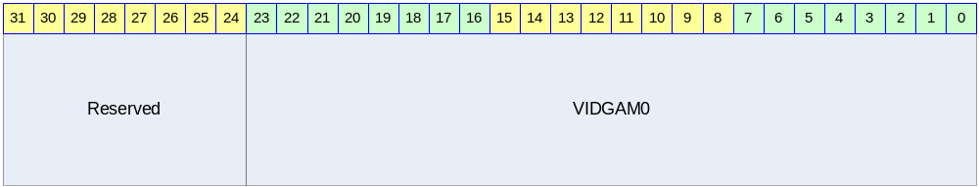

Table 2-40 VGAMMA00 Register Description(Offset : 0000 0200h)
Bits | Name | R/W | Description | Init. Value
[23:0] | VIDGAM0 | RW | Gamma Index0 | 0000 0000h

VGAMMA01 (Graphic Gamma LUT Index) Register

Figure 2-40 VGAMMA01 Register Bits
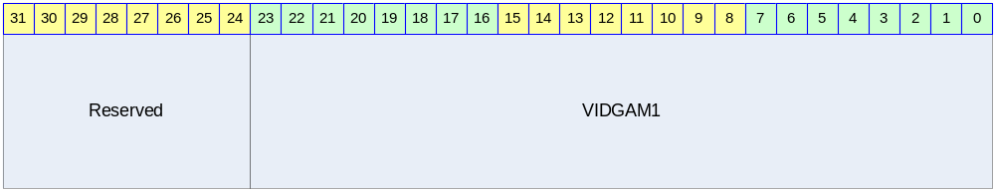

Table 2-41 VGAMMA01 Register Description(Offset : 0000 0204h)
Bits | Name | R/W | Description | Init. Value
[23:0] | VIDGAM1 | RW | Gamma Index1 | 0010 1010h

VGAMMA02 (Graphic Gamma LUT Index) Register

Figure 2-41 VGAMMA02 Register Bits
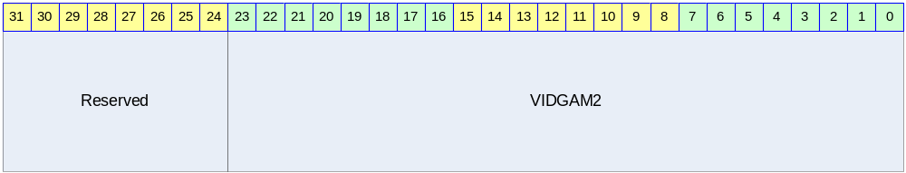

Table 2-42 VGAMMA02 Register Description(Offset : 0000 0208h)
Bits | Name | R/W | Description | Init. Value
[23:0] | VIDGAM2 | RW | Gamma Index2 | 0020 2020h

VGAMMA03 (Graphic Gamma LUT Index) Register

Figure 2-42 VGAMMA03 Register Bits
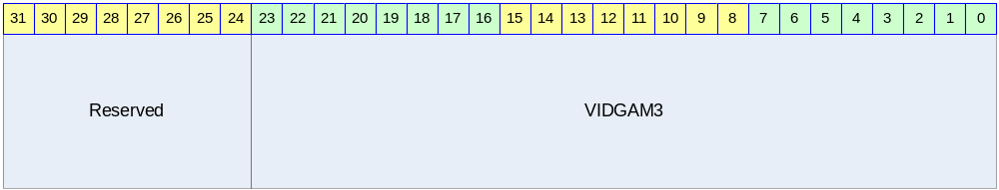

Table 2-43 VGAMMA03 Register Description(Offset : 0000 020Ch)
Bits | Name | R/W | Description | Init. Value
[23:0] | VIDGAM3 | RW | Gamma Index3 | 0030 3030h

VGAMMA04 (Graphic Gamma LUT Index) Register

Figure 2-43 VGAMMA04 Register Bits
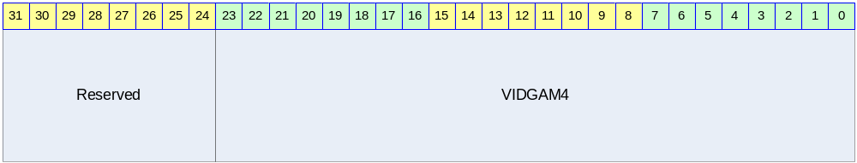

Table 2-44 VGAMMA04 Register Description(Offset : 0000 0210h)
Bits | Name | R/W | Description | Init. Value
[23:0] | VIDGAM4 | RW | Gamma Index4 | 0040 4040h

VGAMMA05 (Graphic Gamma LUT Index) Register

Figure 2-44 VGAMMA05 Register Bits
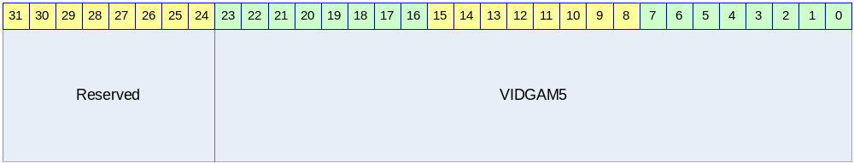

Table 2-45 VGAMMA05 Register Description(Offset : 0000 0214h)
Bits | Name | R/W | Description | Init. Value
[23:0] | VIDGAM5 | RW | Gamma Index5 | 0050 5050h

VGAMMA06 (Graphic Gamma LUT Index) Register

Figure 2-45 VGAMMA06 Register Bits
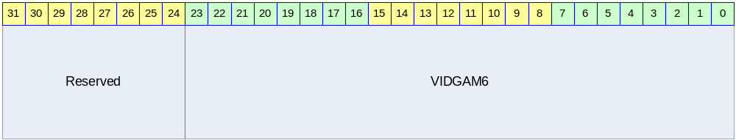

Table 2-46 VGAMMA06 Register Description(Offset : 0000 0218h)
Bits | Name | R/W | Description | Init. Value
[23:0] | VIDGAM6 | RW | Gamma Index6 | 0060 6060h

VGAMMA07 (Graphic Gamma LUT Index) Register

Figure 2-46 VGAMMA07 Register Bits
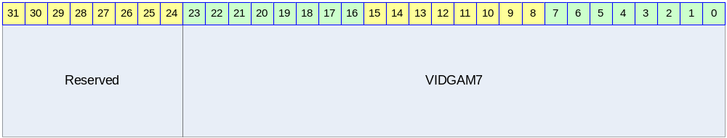

Table 2-47 VGAMMA07 Register Description(Offset : 0000 021Ch)
Bits | Name | R/W | Description | Init. Value
[23:0] | VIDGAM7 | RW | Gamma Index7 | 0070 7070h

VGAMMA08 (Graphic Gamma LUT Index) Register

Figure 2-47 VGAMMA08 Register Bits
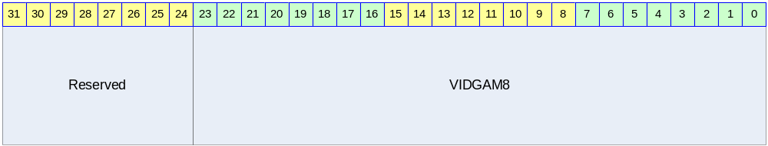

Table 2-48 VGAMMA08 Register Description(Offset : 0000 0220h)
Bits | Name | R/W | Description | Init. Value
[23:0] | VIDGAM8 | RW | Gamma Index8 | 0080 8080h

VGAMMA09 (Graphic Gamma LUT Index) Register

Figure 2-48 VGAMMA09 Register Bits
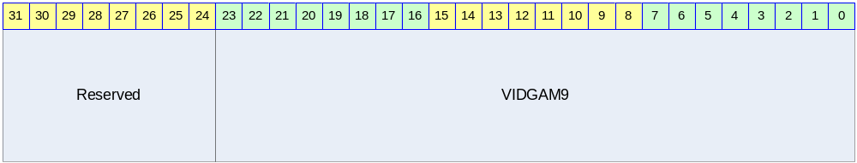

Table 2-49 VGAMMA09 Register Description(Offset : 0000 0224h)
Bits | Name | R/W | Description | Init. Value
[23:0] | VIDGAM9 | RW | Gamma Index9 | 0090 9090h

VGAMMA0A (Graphic Gamma LUT Index) Register

Figure 2-49 VGAMMA0A Register Bits
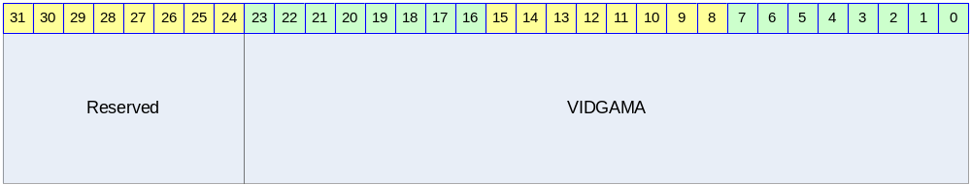

Table 2-50 VGAMMA10 Register Description(Offset : 0000 0228h)
Bits | Name | R/W | Description | Init. Value
[23:0] | VIDGAMA | RW | Gamma Index A | 00A0 A0A0h

VGAMMA0B (Graphic Gamma LUT Index) Register

Figure 2-50 VGAMMA0B Register Bits
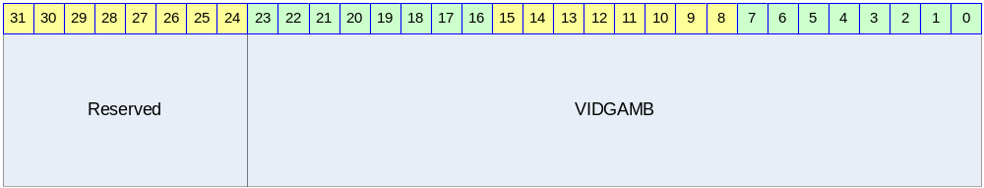

Table 2-51 VGAMMA07 Register Description(Offset : 0000 022Ch)
Bits | Name | R/W | Description | Init. Value
[23:0] | VIDGAMB | RW | Gamma Index B | 00B0 B0B0h

VGAMMA0C (Graphic Gamma LUT Index) Register

Figure 2-51 VGAMMA0C Register Bits
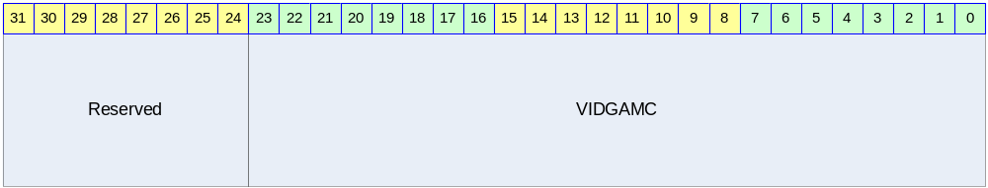

Table 2-52 VGAMMA0C Register Description(Offset : 0000 0230h)
Bits | Name | R/W | Description | Init. Value
[23:0] | VIDGAMC | RW | Gamma Index C | 00C0 C0C0h

VGAMMA0D (Graphic Gamma LUT Index) Register

Figure 2-52 VGAMMA0D Register Bits
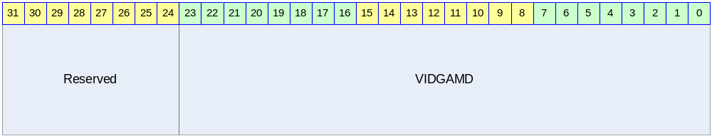

Table 2-53 VGAMMA0DRegister Description(Offset : 0000 0234h)
Bits | Name | R/W | Description | Init. Value
[23:0] | VIDGAMD | RW | Gamma Index D | 00D0 D0D0h

VGAMMA0E (Graphic Gamma LUT Index) Register

Figure 2-53 VGAMMA0ERegister Bits
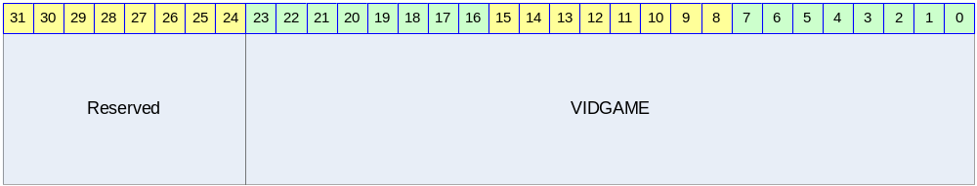

Table 2-54 VGAMMA0E Register Description(Offset : 0000 0238h)
Bits | Name | R/W | Description | Init. Value
[23:0] | VIDGAME | RW | Gamma Index E | 00E0 E0E0h

VGAMMA0F (Graphic Gamma LUT Index) Register

Figure 2-54 VGAMMA0F Register Bits
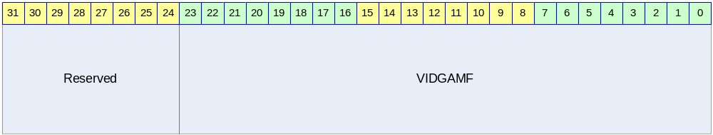

Table 2-55 VGAMMA0F Register Description(Offset : 0000 023Ch)
Bits | Name | R/W | Description | Init. Value
[23:0] | VIDGAMF | RW | Gamma Index F | 00F0 F0F0h

VGAMMA10 (Graphic Gamma LUT Index) Register

Figure 2-55 VGAMMA10 Register Bits
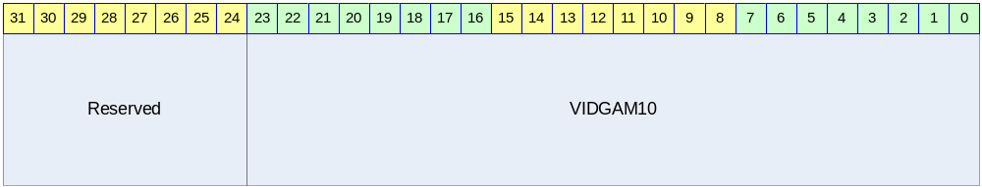

Table 2-56 VGAMMA10 Register Description(Offset : 0000 0240h)
Bits | Name | R/W | Description | Init. Value
[23:0] | VIDGAM10 | RW | Gamma Index 10 | 00FF FFFFh

LCDCON (LCD Control) Register

Figure 2-56 LCDCON Register Bits
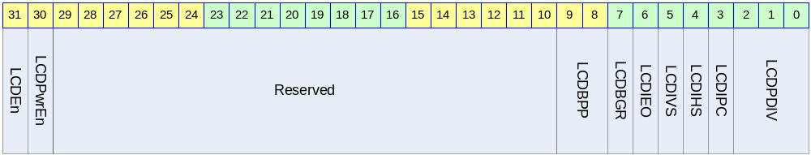

Table 2-57 LCDCON Register Description(Offset : 0000 00E0h)
Bits | Name | R/W | Description | Init. Value
[31] | LCDEn | RW | LCD Sync Enable  0 : Vidoe Sync Enable  1 : LCD Sync Enable | 0
[30] | LCDPwrEn | RW | LCD/Video Data Out Enable  0 : Output Data is Zero  1 : Output Data is Valid | 0
[29:10] |  |  | Reserved
[9:8] | LCDBPP | RW | LCD Pixel Format  0 : 16bpp  1 : 18bpp  2 : 24bpp, Video Sync Mode일 경우 이 값을 설정해야 한다. | 0
[7] | LCDBGR | RW | R/B Swap Enable | 0
[6] | LCDIEO | RW | Invert Write Enable | 0
[5] | LCDIVS | RW | Invert VSYNC | 0
[4] | LCDIHS | RW | Invert HSYNC | 0
[3] | LCDIPS | RW | Invert Pixel Clock | 0
[2:0] | LCDPDIV | RW | 0 : Bypass System Clock  1 : Divide by 2 System Clock  2 : Divide by 3 System Clock  3 : Divide by 4 System Clock  4 : Divide by 6 System Clock  5 : Divide by 8 System Clock  6 : Divide by 16 System Clock  7 : Divide by 32 System Clock | 0

HSYNCCON0 (Horizontal Sync0) Register

Figure 2-57 HSYNC0CON Register Bits
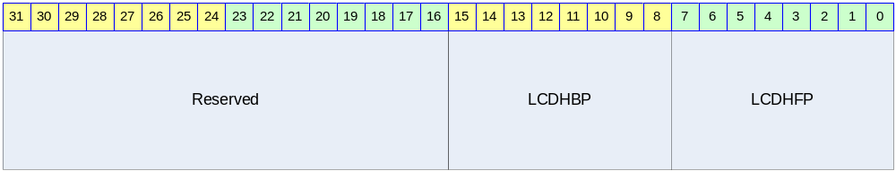

Table 2-58 HSYNCCON0 Register Description(Offset : 0000 00F0h)
Bits | Name | R/W | Description | Init. Value
[31:0] |  |  | Reserved
[15:8] | LCDHBP | RW | Horizontal Back Porch | 0
[7:0] | LCDHFP | RW | Horizontal Front Porch | 0

HSYNCCON1 (Horizontal Sync1) Register

Figure 2-58 HSYNCCON1 Register Bits
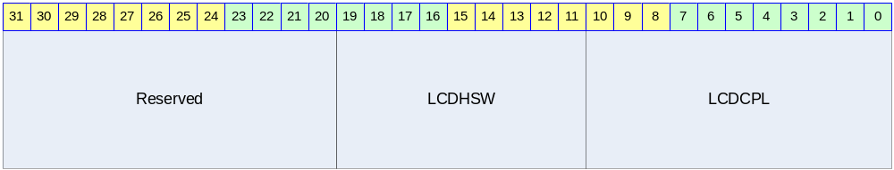

Table 2-59 HSYNCCON1 Register Description(Offset : 0000 00F4h)
Bits | Name | R/W | Description | Init. Value
[31:20] |  |  | Reserved
[19:11] | LCDHSW | RW | Horizontal Sync Pulse Width | 0
[10:0] | LCDCPL | RW | Display Pixel per Line | 2047

VSYNCCON0 (Vertical Sync0) Register

Figure 2-59 VSYNCCON0 Register Bits
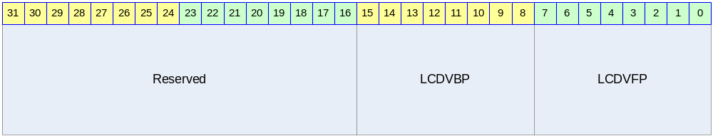

Table 2-60 VSYNCCON0 Register Description(Offset : 0000 00F8h)
Bits | Name | R/W | Description | Init. Value
[31:16] |  |  | Reserved
[15:8] | LCDVBP | RW | Vertical Back Porch | 0
[7:0] | LCDVFP | RW | Vertical Front Porch | 0

VSYNCCON1 (Vertical Sync1) Register

Figure 2-60 VSYNCCON1 Register Bits
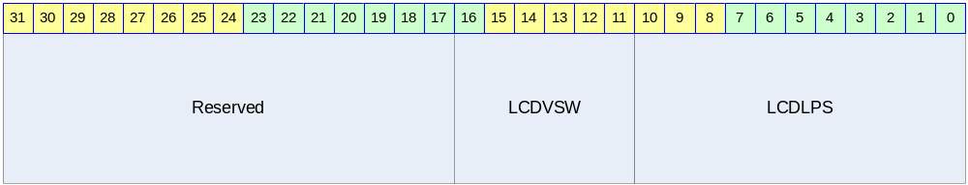

Table 2-61 VSYNCCON1 Register Description(Offset : 0000 00FCh)
Bits | Name | R/W | Description | Init. Value
[31:17] |  |  | Reserved
[16:11] | LCDVSW | RW | Vertical Sync Pulse Width | 0
[10:0] | LCDLPS | RW | Line Display Period | 2047

Operation Diagram

